**COMP 123 Assignment 1**

**By: James Li, Brandon Koo**

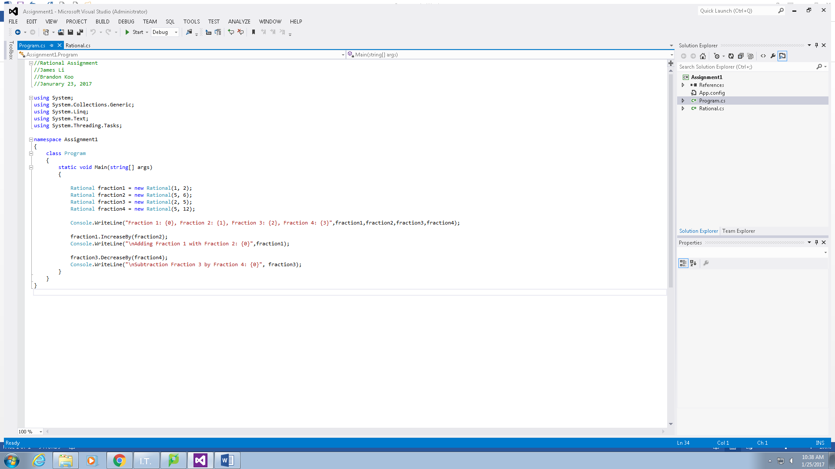

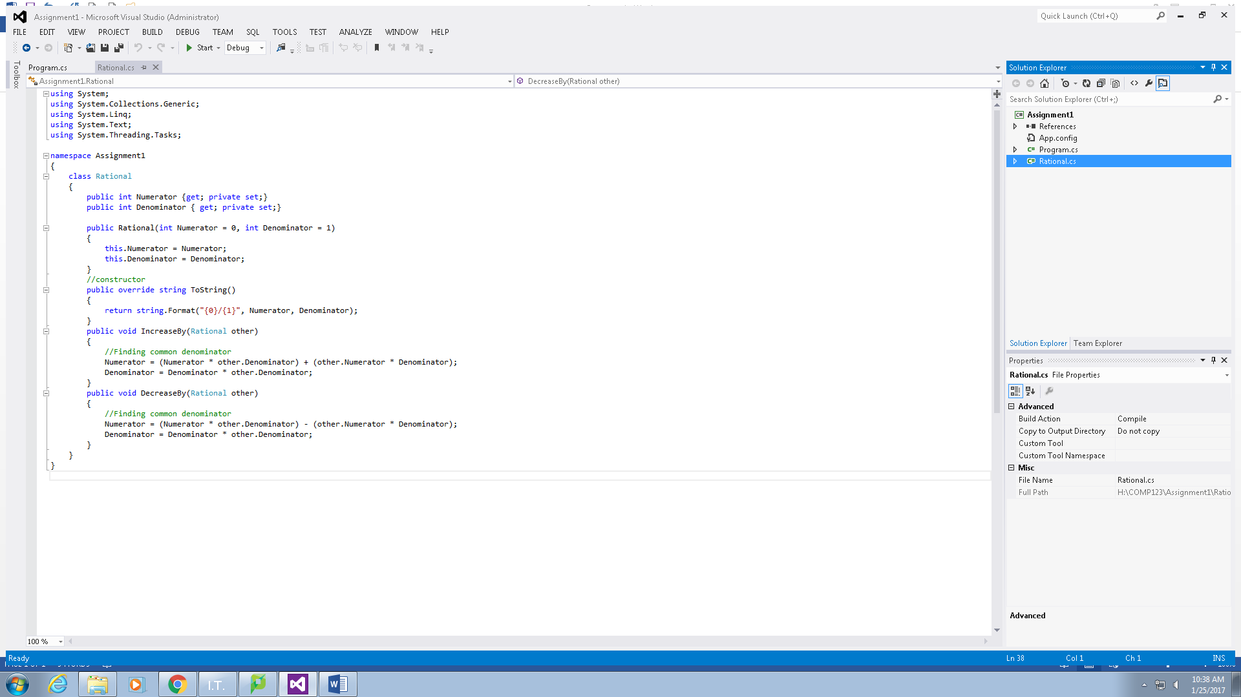

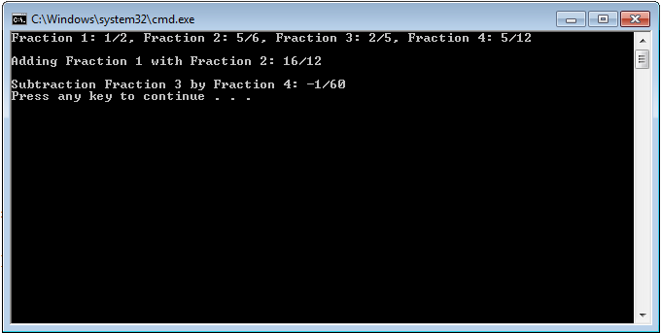

**Program**

//Rational Assignment

//James Li

//Brandon Koo

//Janurary 23, 2017

using System;

using System.Collections.Generic;

using System.Linq;

using System.Text;

using System.Threading.Tasks;

namespace Assignment1

{

class Program

{

static void Main(string[] args)

{

Rational fraction1 = new Rational(1, 2);

Rational fraction2 = new Rational(5, 6);

Rational fraction3 = new Rational(2, 5);

Rational fraction4 = new Rational(5, 12);

Console.WriteLine("Fraction 1: {0}, Fraction 2: {1}, Fraction 3: {2}, Fraction 4: {3}",fraction1,fraction2,fraction3,fraction4);

fraction1.IncreaseBy(fraction2);

Console.WriteLine("\nAdding Fraction 1 with Fraction 2: {0}",fraction1);

fraction3.DecreaseBy(fraction4);

Console.WriteLine("\nSubtraction Fraction 3 by Fraction 4: {0}", fraction3);

}

}

}

**Rational**

using System;

using System.Collections.Generic;

using System.Linq;

using System.Text;

using System.Threading.Tasks;

namespace Assignment1

{

class Rational

{

public int Numerator {get; private set;}

public int Denominator { get; private set;}

public Rational(int Numerator = 0, int Denominator = 1)

{

this.Numerator = Numerator;

this.Denominator = Denominator;

}

//constructor

public override string ToString()

{

return string.Format("{0}/{1}", Numerator, Denominator);

}

public void IncreaseBy(Rational other)

{

//Finding common denominator

Numerator = (Numerator * other.Denominator) + (other.Numerator * Denominator);

Denominator = Denominator * other.Denominator;

}

public void DecreaseBy(Rational other)

{

//Finding common denominator

Numerator = (Numerator * other.Denominator) - (other.Numerator * Denominator);

Denominator = Denominator * other.Denominator;

}

}

}